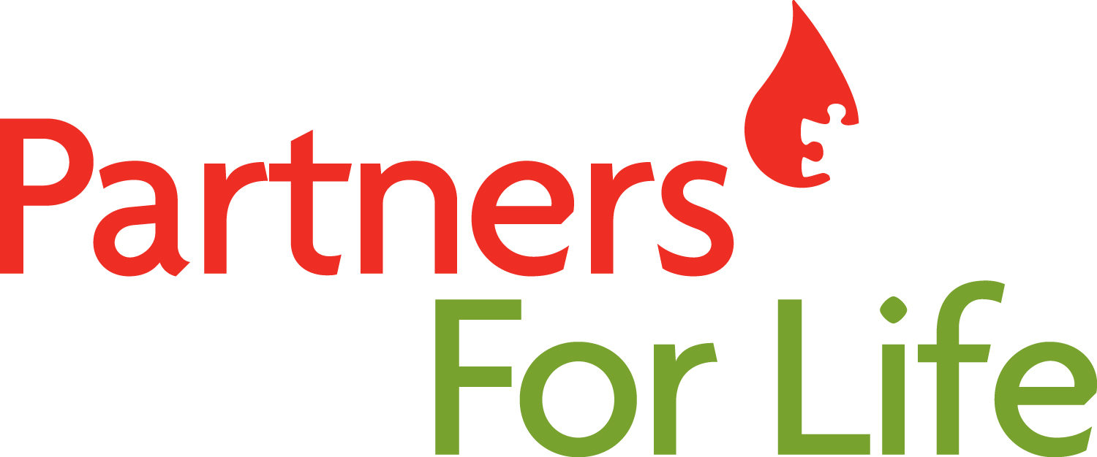

Corporate Partners for Life

Champion to Company

Kick-Off Evite Suggested Copy

Here’s something you may not know: our company has partnered up with Partners for Life – a national program committed to saving lives through blood donations.

We’ve got it in us to work together and reach a donation pledge of <XX> units of blood for the year to help contribute to Canada’s blood supply.

Come and see what it’s all about at our kick-off event on <date>. You’ll find out how you can donate, ask your coworkers who have previously donated what it’s like and even have a cookie or two.

Registration Email Suggested Copy

Subject line: Let's do something amazing

Alts: Guess what we can do together?
Together we can save lives
Partner up with Partners for Life

Email lead:
Head: It can take only 2 units of blood to help someone who needs brain surgery.
If you and 5 coworkers donated, we could save 3 lives.

Alts: Subject line: 85% of our coworkers will read this email
Head: If all of them donated blood, we could help save <hundreds> of lives.

Subject line: There are 78 keys on your keyboard
Head: If that many coworkers donated, we could help 15 people in cancer treatment.

Subject line: There are 40 keys on most smartphones.
Head: If those were blood donors instead, we’d help 8 cardiovascular surgery patients.

Copy:
Hi colleagues,

Here’s something you may not know: our company has partnered up with Partners for Life – a national program committed to saving lives through blood donations.

We’ve got it in us to work together and reach a donation pledge of <XX> units of blood for the year to help contribute to Canada’s blood supply.

Come and see what it’s all about at our kick-off event on <date>. You’ll find out how you can donate, ask your coworkers who have previously donated what it’s like and even have a cookie or two.

As your Champion, I have more information about the program and can answer any questions you may have about donating. In the meantime, let’s roll up our sleeves for our first blood donor clinic:

- <date>
- <location>
- life bus schedule [links to schedule]

Ready to be a donor? Register as a member of our team with this Partner ID#: XXX000 and help Canadian Blood Services track the number of donations.

Register now [links to blood.ca/joinpartnersforlife]

Just think – together we can do something pretty incredible. We can save lives.

Thank you!
<name>
Your Champion contact

Motivation Email Post Kick Off

Copy:

Join our team and help contribute to our goal of <XXX> units collected with Partners for Life. To become a donor, register at www.blood.ca today!

Our first blood donor clinic is:

<date>
<time>

